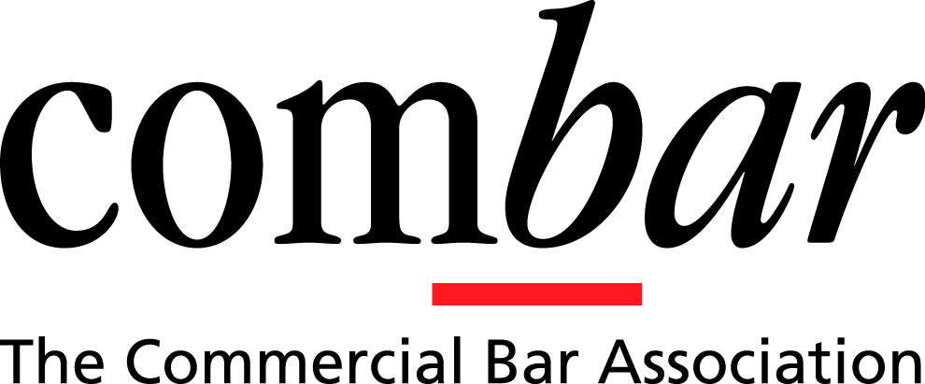

Full-time Administrator for the Commercial Bar Association (COMBAR)

The Commercial Bar Association (COMBAR) is looking for an experienced full-time senior administrator starting in February or March 2022. There will be approximately a four month handover period.
The main duties of the administrator over the course of the year include
- Support to the officers
  - Providing general support to the Chair, Vice-Chair, Secretary and Executive Committee
  - Minuting the Executive meetings (held monthly) and sub-committee meetings
  - Co-ordinating the administration of monthly continuing professional development lectures including email advertising, reminders and booking of venues
  - Assisting in the preparations for the AGM (end July).
  - Communicating with Court, regulatory, governmental and representative bodies in response to queries about consultations, events, schemes and other business
- Membership management
  - Managing the annual COMBAR membership renewals and subscription payments (November)
  - Dealing with membership applications in collaboration with the Secretary of COMBAR
  - Maintaining contact lists of members and Honorary Overseas Members
  - Co-ordinating the international grant programme for Junior COMBAR members
  - Working with Inner and Middle Temple on the student scholarship Programme
- Event management
  - Assisting the relevant sub committees in organising the annual overseas North American Meeting (June) and India Roundtable Meeting (September)
  - Organising and booking travel arrangements for VIP guests for these events
- Administration
  - Assisting the relevant sub committees in managing the website, posting news, recordings and events
  - Providing input where necessary to the eNewsletter for distribution to the membership
  - Liaising with the COMBAR accountant in the preparation of the end of year accounts and annual budget
  - Being responsible for ordering stationery, office insurance etc, as and when required
  - Communicating via email or phone with enquiries from the COMBAR membership or general public

Reporting to the Chair, Vice-Chair and Secretary of COMBAR, the ideal candidate should accordingly have the following:
- Proven senior administrative experience
- Strong organisational and planning skills
- Excellent time management skills and the ability to multi-task and prioritise work
- Ability to work independently without supervision
- Attention to detail and problem solving skills
- Excellent written and verbal communication skills
- Knowledge of office management systems and procedures
- Proficiency in the MS Office suite of software
- The ability to work comfortably under pressure
- Experience of liaising with senior members of the legal profession both in the UK and abroad
- Basic book keeping skills working alongside the accountant
- Ability to manage budgets and communicate with the bank
The successful candidate will be entitled to private healthcare and 25 days paid holiday per annum.

Salary: £66,500 (basis five days a week) together with a pension contribution equivalent to 3% of salary.

COMBAR is willing to discuss the successful candidate working in part from home and in part from its offices at Outer Temple Chambers. COMBAR is also willing to consider a candidate who wished to work four days a week, provided that there was flexibility at certain specifically identified periods of the year.

Please send a covering letter and recent CV to Veronica Kendall at admin@combar.com. The deadline for applications is 5pm, Friday 3 December 2021. The successful candidates will be shortlisted and interviews will take place in December 2021/early January 2022.

